PHEROMONE
(A means of communication)

According to Karlson (1960) Cheminal signals exchanged between individuals of the same species are pheromones which cause a specific reaction either in the form of behavioural response or in a particular developmental process.
The term Pheromone was originally applied to the sex attractants of insects but now it includes all kinds of chemical substances released into the environment to aid in the integration of behaviour among members of the same animal species.
Characteristics of Pheromone-
- It is produced by exocrine glands
- It is transmitted via the external environment
- It is more species specific.
- It evokes specific behavioural , developmental, or reproductive responses in the bodies of other individuals of the same animal species
- In general pheromone acts on the hypothalamus via olfactory pathways and thereby alters the behaviour of recipient.
Types of pheromones-
On the basis of their mode of action pheromones are grouped in to two categories. These are –
I) Signaling or releaser pheromones
The pheromones that produce a simple ‘releaser’ effect i.e a single, rapid, specific, response mediated directly by the central nervous system, are called releaser pheromones.
These includes
a) Sex Pheromones or Sex attractants – Among insects the sex attractants have been identified in silk moth, gypsy cockroach, honey bee and mosquitoes. Female silk moth (Bombyx mori) secrete a sexual attractant, bombycol
: CH₃-(CH₂)₃ – CH =CH- CH = CH – (CH₂)₈ – CH₃OH.
Only the antennal chemo receptors of male are excited by this substance, those of female are insensitive. When sensed by male a behavior pattern is initiated in such a way that male flies to the female.
Many studies have been made on the sexual attractants of Gypsy moth, whose females secrete the pheromone Glypure.
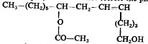

Other example of Sex pheromones-

- Female producing Sex pheromones – Neptalactione(aphids), 3-methylene 7-methyl 7-octen propanoate(scale insect), Butyl butyrate (mired bugs), E 2, 9-oxodecanoic acid(honeybees), Periplanon-B secreted from female Cockroaches, 2-heptanone(ant Iridomyrmex pruinosus), bombykol(Bombyx mori), glyplure(gypsy moth), Periplanone-B(Cockroaches), etc
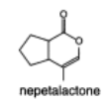  (aphids) | 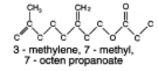  (scale insect)
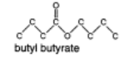  (mired bugs) | 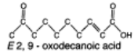(honeybees)
- Male producing Sex pheromones – eg 3,7-dimethyl-2-tridecanol(pine sawflies), Nerol /Homonerol + aliphatic alcohol(Male antlions) etc
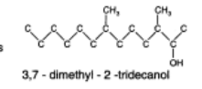
pine sawflies
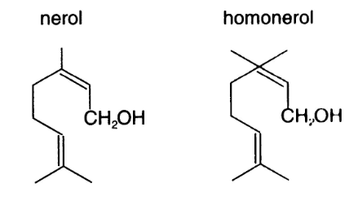
Male antlions
b) Dispersal or aggregation pheromones- eg Quinones (Flour beetles), Geraniol(Honeybees)
c) Marking Pheromones- These are used by social insects to define feeding or nest sites and to mark trails. Non social insects use it to mark position occupied by eggs. These are less volatile and more persistent in nature. These are of following types
- Oviposition making pheromones- these are used by insects to mark their egg laying sites to inhibit further oviposition in the same place or same host. Eg Heneicosane secreted from dofour’s gland of parasitic wasp, N-taurine secreted from midgut of fruit fly, Linoleic acid(codling moth), miriamide (Cabbage buterfly) etc
Epideictic pheromones- pheromones which the members of a population to become more widely spaced are sometimes called epideictic hormones. Larvae of the flour moth, Ephestia produce a pheromone from
- their mandibular glands when they encounter other larvae of the same species.
- Trail Pheromones – these are used to make track which is used by other members of the species to follow. Mainly secreted by ants and termites. Eg 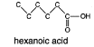 (from the hind gut of ant)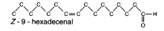
When worker honey bee finds the good source of food, they release pheromones from an abdominal scent gland to aid other workers in finding the food.
d) Alarm Pheromones- These are produced as a response to disturbance in colony by enemies or other way. These are highly volatile compounds and mixture of several compounds. These are less specific then other category of pheromone.
The effect of alarm pheromone in non social insects is to cause dispersal. Aphids, for example, may fall from their host plant when they perceive the alarm pheromone. Amongst social insects, the response varies according to species, but commonly involves attraction of other workers or soldiers and the adoption of aggressive postures with the head raised and jaws wide apart.
An alarm pheromone is produced In the mandibular glands of Apis is released via sting chamber. Guard bee at the entrance to hive uses this to mark intruders and to stimulate aggressive activity by other bees.

The ant Iridomyrmex pruinosus uses 2- heptanone as an alarm pheromone.
Examples of alarm pheromone –
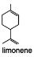 | 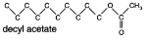 |  | 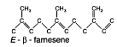
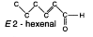 |  | 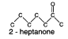 | 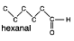
2) PRIMER PHEROMONES – The Pheromones which trigger a chain of physiological events, or those that activate a long series of neuroendocrine events that develop slowly and require prolong stimulation, are called Primer Pheromones.
The Primer Pheromone often act by physiological inhibition but can produce the opposite effect,
For example, adult male of migratory locust secrete a volatile substance from their skin and accelerate the growth of young locust and thus play an important role in the formation of migratory locust swarms.
Mabndibular glands of honey bee queen secrete a pheromone 9-ketodecanoic acid. When this is ingested by worker bees it shows a primer effect inhibiting the development of ovaries.
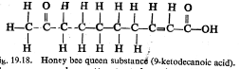

Example of mammalian pheromones – Pheromones are identified in various terrestrial animals including mammals and human. The sex attractants of civet and muskdeer are called civetone and muskone respectively. The cavieton is secreted from the para-anal glandular pouch and is used for defense and territory marker.
The muskone function as a sexual attractants.
The main source of human sex pheromones are some odoriferous glands in skin, including the mammary gland, glands of external auditory gland and the glands of pubic region etc. Saliva urin , tears, etc may contain pheromone like compounds. Exaltolide a synthetic analogue of mammalian sex attractants 14-hydroxy tetradecanoic acid is perceived only by adult female.
IMPOTRANCE OF PHEROMONES- Pheromones are used-
- As a means of communication in lower organisms where other means of communication like visual, verbal, posture changing tactile, are under developed.
- To attract or call opposite partner.
- To form colony
Thus pheromones play important role in the life of animals especially in insects

Prof (Dr) RAKESH MOHAN , Email rzoornc@rediffmail.com

